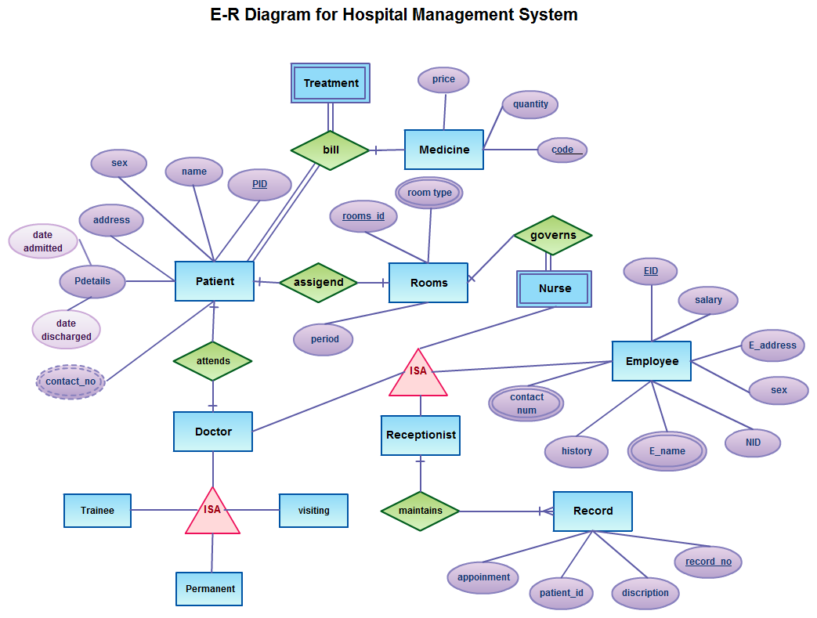

**Step 1: E-R Diagram of Library Management System**

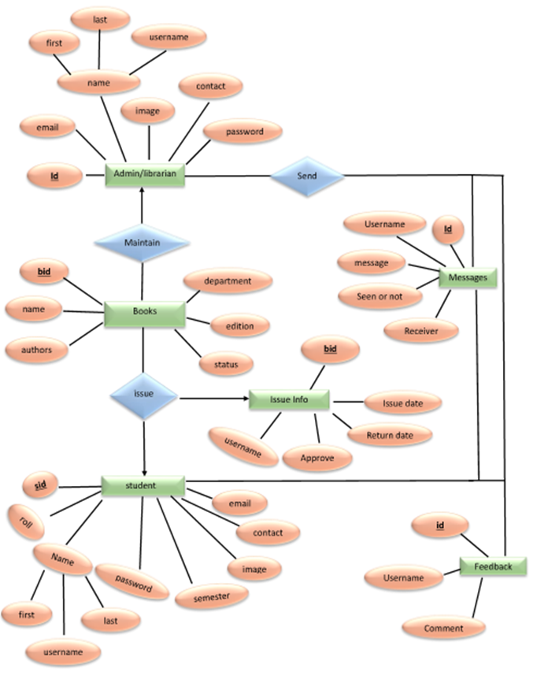

**Step 1: E-R Diagram Student management system**

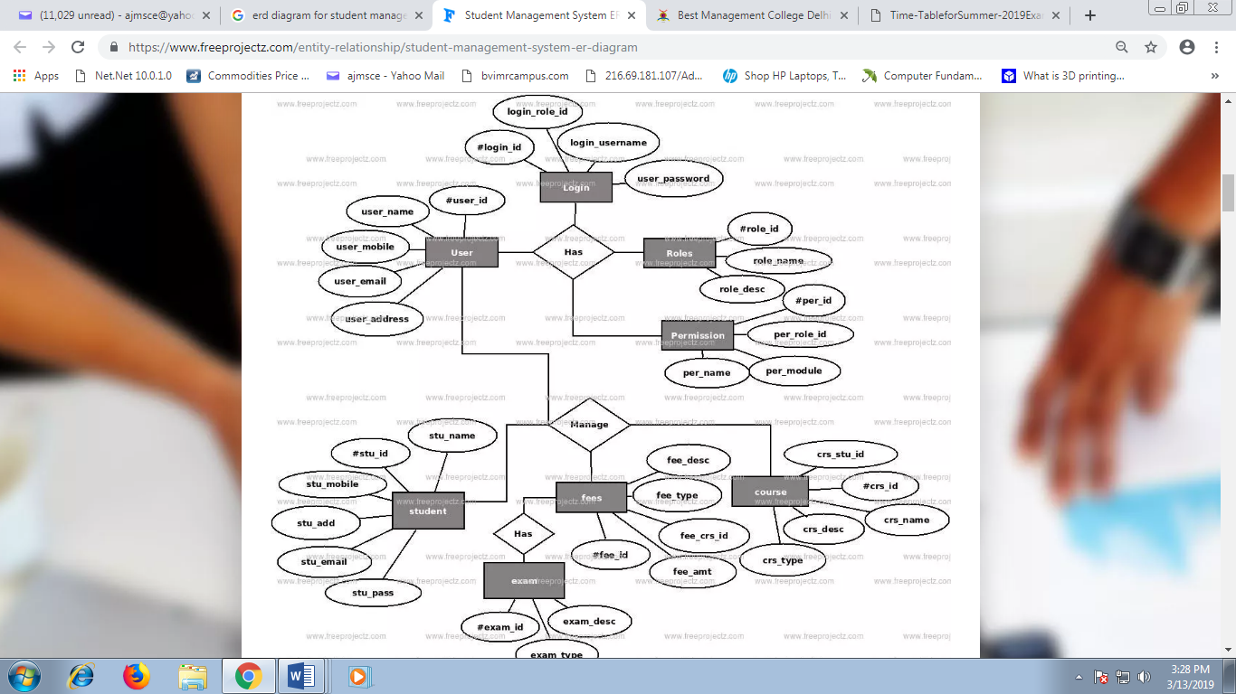

**Step 1: E-R Diagram of BUS/ train ticket booking system**

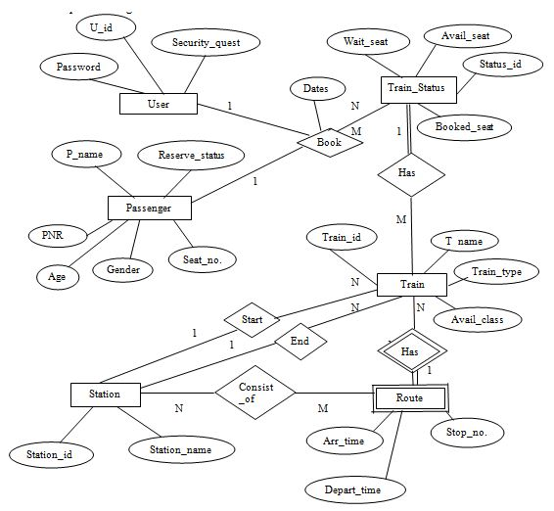

**USER**

| **U_id** | **Primary Key** |
| --- | --- |
| Password |  |
| Security_quest |  |

**Passenger**

| **PNR** | **Primary Key** |
| --- | --- |
| P_name |  |
| Age |  |
| Gender |  |
| Seat_no. |  |
| Reserve_status |  |
| U_id | Foreign key references to U_id of User table. |
| Status_id | Foreign key references to Status_id of Train_Status Table. |
| Train_id | Foreign key references to Train_id of Train Table |

**Train_Status**

| **Status_id** | **Primary Key** |
| --- | --- |
| Wait_seat |  |
| Avail_seat |  |
| Booked_seat |  |
| Train_id | Foreign key references to Train_id of Train Table |
| PNR | Foreign key references to PNR of Passenger table. |

**Train**

| **Train_id** | **Primary Key** |
| --- | --- |
| T_name |  |
| Train_type |  |
| Avail_class |  |
| Status_id | Foreign key references to Status_id of Train_Status Table. |

**Route**

| **Arr_time** |  |
| --- | --- |
| Depart_time |  |
| Stop no. |  |
| Station_id | Foreign key references to Station_id of Station table. |
| Train_id | Foreign key references to Train_id of Train Table |

**Station**

| **Station_id** | **Primary Key** |
| --- | --- |
| Station_name |  |

**Step 3: Mapping of Attributes**

a. **Simple Attributes**

Simple attributes which cannot be divided into subparts.

**Example:** Seat Number of passenger

b. **Composite Attributes**

Composite attributes which can be divided into subparts.

**Example:** Passenger Name, Reservation status

**P_name**

| **First_Name** |
| --- |
| Middle_Name |
| Last_name |

**Reserve_status**

| **Waiting** |
| --- |
| Confirmed |

**Step 5: Mapping of Relationships**

a. **Foreign Key approach**

**Passenger_Table**

| **U_id** | **Passenger table makes foreign key references to U_id of User table.** |
| --- | --- |
| Status_id | Passenger table makes foreign key references to Status_id of Train_Status Table. |
| Train_id | Passenger table makes foreign key references to Train_id of Train Table |

**Train_Status**

| **Train_id** | **Train_status table makes foreign key references to Train_id of Train Table** |
| --- | --- |
| PNR | Train_status table makes foreign key references to PNR of Passenger table. |

**Train**